Learning Curves
Training an algorithm on a very few number of data points (such as 1, 2 or 3) will easily have 0 errors because we can always find a quadratic curve that touches exactly those number of points. Hence:
- As the training set gets larger, the error for a quadratic function increases.
- The error value will plateau out after a certain m, or training set size.
Experiencing high bias:
Low training set size: causesto be low andto be high.
Large training set size: causes bothandto be high with.
If a learning algorithm is suffering from high bias, getting more training data will not (by itself) help much.
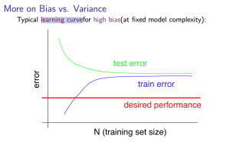
Experiencing high variance:
Low training set size:will be low andwill be high.
Large training set size:increases with training set size andcontinues to decrease without leveling off. Also,but the difference between them remains significant.
If a learning algorithm is suffering from high variance, getting more training data is likely to help.
